Table of Contents

1 Introduction 3
1.1 Purpose 3
1.2 Scope 3
1.3 Server Requirements 3
2 Installation Manual 4
2.1 Pre-requisites 5
2.2 Pre-installation Tasks 6
2.3 Installation Procedure 6
2.4 Post-installation 8
2.5 Technical Tests 8
2.6 Uninstall or Roll-back 9
3 Additional Information 10
3.1 Document Revisions 10
3.2 Reference Documents 10

Introduction

Purpose
This document is provided to serve as installation guidelines for the Drupal 7 Content Management System.
The objective of this document is to set up a functioning Drupal 7 base installation.
An inadequate, incomplete or inexistent install procedure may lead to
website instability and data loss. Check prerequisites and pre-install checklist before proceeding.

Scope
This document is intended to direct and assist a novice user with the detailed set-up of the Drupal 7 Content Management System.
It will not cover detailed aspects such as module and theme installation, Drupal Core configuration, or updates to themes, modules, or the Drupal Core environment.

Server Requirements
To install and run Drupal 7, the following requirements must be met: [1]
- Apache version 2.0 or greater
- PHP 5.2.0 or greater
- MySQL 5.0 or greater, PostgreSQL 8.3 or greater, or SQLite 3.4.2 or greater

Failure to meet these requirements will cause installation failures or a non-operable installation of Drupal 7.

Installation Manual

Pre-requisites
Before beginning the installation of Drupal 7, verify that the following are available and configured for use:
- Web server (Must meet server requirements outlined in section 1.3)
- FTP Software
- Stable internet connection
- Any archive software (WinRAR, 7-zip, etc)
- Any text editor
- Web browser with internet access

Pre-installation Tasks
Before installation, visit www.drupal.com/start and download the latest release of Drupal 7. It will be available for download as a tar.gz or a zip file. Either will work, but some archive managers only support the zip format. Refer to your software manual to determine which file format(s) are supported.
For the purposes of this installation it is going to be assumed that there is an active domain and an empty directory available and properly configured to host this website.

Installation Procedure

Initial File Setup
- Extract the installation files from the archive using your archive manager.
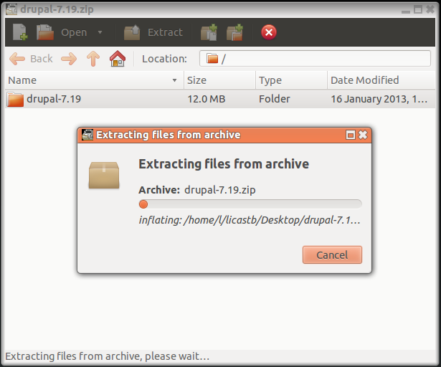
- Move the extracted files into a directory within your web servers public HTML directory or document root. [1]
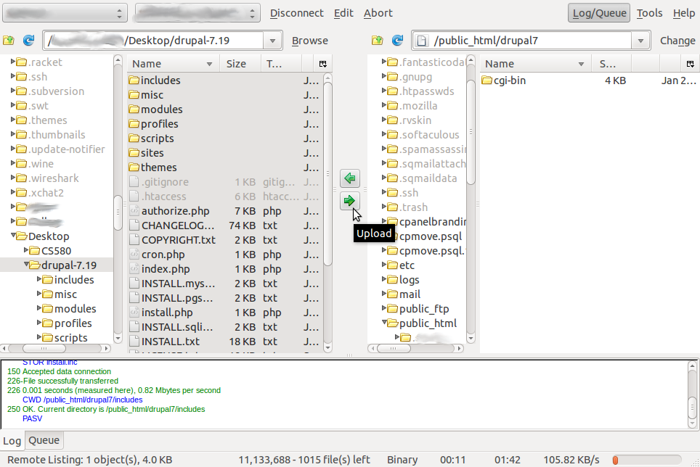
- Create a configuration file by copying the example, named default.settings.php (located in the sites/default directory of the extracted files). Rename the copied file to settings.php. [1]
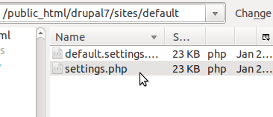
- Give the web server write privileges (644) for the settings file. [1]
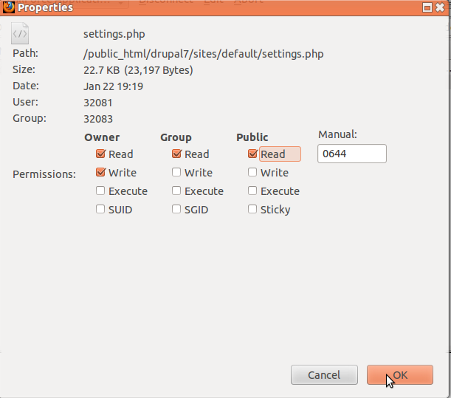
The initial file work has been completed. We will return to settings.php later to configure the database.

Database Setup
To set up a database for your Drupal 7 installation, log in to your database management software of choice. For this installation walk-through we will be using the integrated Cpanel database tools.

Configuration
Indicate all the configuration parameter used by the application that is being installed so it works correctly into the OP systems and environment. Please double check that this values correspond (in terms of server names, IP addresses, folder architecture and files locations, …) to what is existing at OP, and not to your tests environment and/or server.
Most configuration tasks include, but are not limited to, the following:
- properties / configuration files;
- environment variables;
- one-shot scripts;
- …

Application Server:
BEA / TOMCAT must be compliant to the standard procedures at OP.
A special mention must be set on the backup of all elements that are being handled for the current delivery, in order to proceed to a uninstall if necessary

Post-installation
The installation instructions should contain a check list that details
- the list of all files modified during the installation
- the location of the configuration files; a list of useful parameters; if necessary, global configuration files will be used in order to avoid multiple definitions of the same parameters/variables
- the list of periodic jobs to schedule
- a procedure to check the correct installation/working of the application: basic checks to be performed by the person in charge of the installation should allow to check if the application is behaving correctly without requiring a full functional validation.

Technical Tests
Adequate testing prior release to production is necessary to check not only functional aspects of the delivery but also not-functional ones.
Contractors should include in the delivery a separate folder with all the necessary test files, tools, scripts, …, and a complete well formed test plan procedure, that can be handled by the test team.
The test plan should be linked to the delivery package it belongs to, describe the purpose of the tests, and should mention in an unambiguous way the correct environment prerequisites and information, the location of the data source needed as input (if any), the actions to perform and the expected results, the output files location (if any).
Some tests might need to be performed before delivery install: mention of this particular situation should be included in the test plan, in order to inform the people concerned.
Remark:
Test must be executed at the Publications Office: contractors must keep in mind that tests performed at their premises may differ because of a system environment, tools version, …, differences.
A comparative check between the two systems should be done before delivery in order to avoid errors.
As an example the test plan could be formatted the following way:
[Test Case | [Test Case Title]
Description | [brief description of the test case]
Actors | [list of actors and user roles required to run the test case]
Preconditions | [constraints on the system that have to be satisfied before the test case can be executed]  for example, input or location of data source
Start Date and Time
End Date and Time
Steps
Step 1 | [action to be taken, task to be executed]  for example: Connect to server2 as “user1”
Step 2 | From the main installation package, extract the following to an empty temporary directory on the server2 server:  - Install/user1/_this_release_bin.opoce.tar
Step 3 | From the test folder, execute the script as follow:  ./testrelease.sh input/new_files/TEST_THIS_FILE
Step 4 | verify results
. . .
Expected Results | [the expected outcome of the test case]
Actual Results | [test case successful yes/no? expected result met?]

Uninstall or Roll-back
A detailed procedure how to uninstall the application should be provided that follows the same general remarks as the installation procedure.
The rollback procedure must be as clear and explicit as the install procedure, as it must allow undoing all changes to the situation before the installation has been performed.
The same rules apply concerning the steps to execute to re-establish the old application delivery.
As an example the same format and method used for the install procedure can be followed to describe the rollback.

Additional Information

Document Revisions
Date * Revision Number | Description
1.20.2013 * 1.0 | Document initially created.
1.22.2013 * 1.5 | Changed formatting and added database directions.
1.23.2013 * 1.5.1 | Fixed autocorrect typo and several minor grammatical errors.

Reference Documents
[1] Sea, Eric. "Quick Install for Beginners." Drupal. Drupal.org, 13 Aug. 2012. Web. 22 Jan. 2013. <http://drupal.org/documentation/install/beginners>.

